**University of Technology and Applied Science**

**Higher College of Technology**

**Department of Information Technology**

**Internet and E-Security Specialization**

**Cyber Security E-learning system**

**HCT Academy**

**In Partial Fulfillment of the Requirements for B.Tech Degree**

**With Specialization in Internet and E-Security**

**Submitted By:**

Hisham Rashid said al Ghawi 16s162769

Asma Abdullah al-Shamsi 76s16453

**Under the guidance of**

Main Supervisor name

Secondary Supervisor name

**Semester 1 / 2020-2021**

**Table of Contents**

Table of Figures ii

Table of Tables iii

Glossary: iv

Chapter 1:Introduction 4

1.1 Project description 4

1.2 Problem statement 4

1.3 Aims and objectives 5

1.4 The significance of the project (optional) 5

1.5 Used Tools (HW and SW) 5

1.6 Work plan for one year project 5

**2.Literature Review** 6

2.1 Background 6

2.1.1 What is a “E.g: Firewall” ? 6

2.1.2 Component and element involve 7

2.1.3 How it works? 7

2.1.4 Other related technology involved 9

2.1.5 Other information 10

2.2 Related Work 11

2.2.1 Similar projects analysis 11

2.2.2 Similar projects comparison 12

2.2.3 How the proposed system is different from the existing systems 13

**Table of Figures**

Figure 1:Action Plan 5

Figure 2:fundamental functionality 7

Figure 3:Comparisom table of the Firewall 8

**Table of Tables**

Table 1:Specific firewall filtering rules. 9

Table 2:comparison with other firewall 11

# Glossary:

SQL Structured Query Language

XSS Cross site scripting

URL Uniform Resource Locators

HTML Hypertext Markup Language

CSRF Cross-site Request Forgery

OS Operating system

2FA Two-factor authentication

DOS Denial of Service

DDOS Distributed Denial of Service

OSINT Open-source intelligence

LFI Local File Inclusion

# …

# Chapter 1: Introduction

## 1.1 Project Description:

HCT Academy. The platform system will be as a reference for the student to understand their lessons and also a practical practice for them. it has different levels. each level of Academy can help student to upgrade their level and get more practical experience in Cyber security.

## 1.2 Problem statement:

## This project is trying to solve the problem of students who has no experience in information security, and teach them practical experience.

## 1.3 Aims and objectives:

This project is trying to achieve many objectives to make the student learn some types of attacks and how it is done, and how to mitigate.

## 1.4 The significance of the project:

Our project will offer,

سنترلايز بليس

Penetration system in cloud (kali Linux).

Explain the idea of the Cyber-attack (challenge) in a simple way before starting

Apply the points system after solving the challenges

Upgrade the student's level after solving the challenges

* noob > script kiddies > hacker > pro

offline CTF challenge. ex crypto, steganography

## 1.5 Used Tools (H.W and S.W):

### 1.5.1 Hardware Requirements

* Laptops, PC, server, cloud platform.

### 1.5.2 Software Requirements

* Programming language (html,php)
* Database (Xamp-mysql)
* Application (Visual Studio Code, Notepad++, VMware Workstation Pro)
* AWS cloud platform.

## 1.6 Action Plan

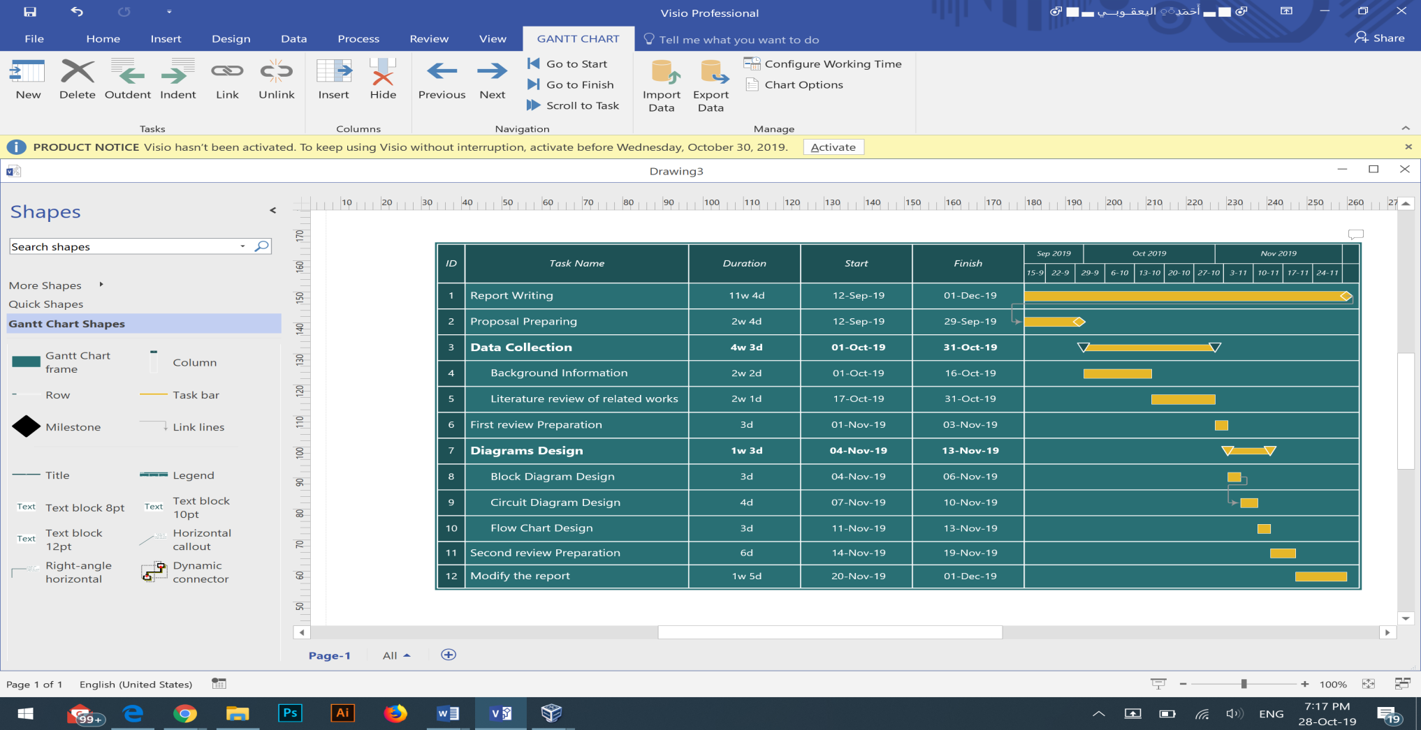

Table 1:Action plan

## 1.7 Project Risk & Limitation (optional)

* Abuse the platform.
* Abuse the cloud system (kali).

# Chapter 2: Literature Review

## Background Information

### 2.1.1 What is “Firewall”? (Please use your project main topic)

It is a way of [5]

Figure 4, Tool Objectives [3]

Figure 1:

Figure 2: [8]

### 2.1.2 Why it is used

### 2.1.3

Table 2:Applications

Table 3:limitation and illegal activities

### 2.1.4

### 2.2.1 Similar projects analysis

TryHackMe: - is an online platform that teaches cyber security through short, gamified real-world labs. they have content for both complete beginners and seasoned hackers, incorporating guides and challenges to cater for different learning styles. TryHackMe had created as a way to get others learning cyber security in an enjoyable and interactive way .and allows individuals with different skill sets to learn at their own pace.

### 2.2.2 Similar projects comparison

### 2.2.3 How the proposed system is different from the existing systems

### 

# 3 References

|  |  |
| --- | --- |
| [1] |  |
| [2] |  |